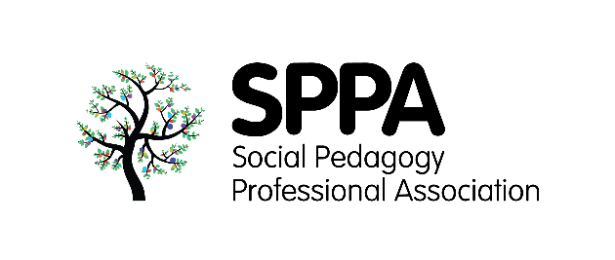

**Project Bank at SPPA Conference**

SPPA members belong to a learning community. We have the opportunity to learn from each other and to support each other’s learning. One way of doing this is to create a Project Bank, on the website, where we hold information about projects that are ongoing and members can ask questions, find partners and exchange ideas. To get this going we need to get some projects loaded. Projects can be large or small, single person or multi-person, self-funded or externally funded. When giving SPPA information you should be mindful of any confidentiality issues, especially around personal contact details. The information will be on a member’s only protected area of the website but this does not guarantee complete data security.

Please complete the details below, so far as you are able.

**Title of project:**

1. What questions are being asked in this project? What do you want to know?
2. What are the aims and objectives of the project?
3. Who are the target groups? Whose lives or work do you want to improve?
4. What areas of the country are you working in?
5. How are you doing the project? What methods are being adopted?
6. What do you expect to find out?
7. When do you start and finish the project?
8. I am looking for partners to …. /or in areas of the country …. /or support with
9. I can offer help with ….

**Complete the details to submit your interest and send it to** [**sppa@ucl.ac.uk**](mailto:sppa@ucl.ac.uk)**:**

**Name:**

**Email address:**

**Phone Number:**

**How would you like to be contacted (phone/email):**

We will collate information from many and varied social pedagogy projects and contribute to practice based evidence of social pedagogy in action. We will post the information on the SPPA website and let you know so you can check it and wait for you responses to come in