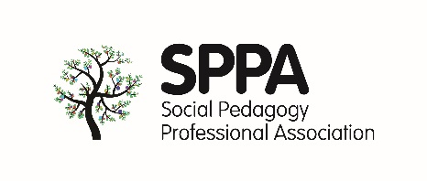

**SPPA Case studies for social pedagogic practice in the UK**

We would like to introduce inspirational case studies to the SPPA website. We are asking SPPA members and invited others to write about their work in relation to social pedagogy. Please be concise and complete all the sections you can. If you have good quality photographs or images please supply. We are happy to write this with you via a telephone or Skype call if you prefer. Just drop us an email at [sppa@ucl.ac.uk](mailto:sppa@ucl.ac.uk). The whole case study should be no more than two sides of A4. We may have to edit if they are longer.

**Title of case study [occupation, project]**

**Participants/team [names and/or job titles]**

**Setting [occupational field, e.g. youth work, older people’s care etc.]**

**Social pedagogy knowledge/learning if any [training, qualifications, short courses, learning opportunities]**

**Please briefly describe your project or work**

**How do the values and principles of social pedagogy influence your day to day practice? [See** [**SPPA Charter**](http://www.sppa-uk.org/about-us/social-pedagogy-charter/) **for guidance]**



**Can you give one or two examples of practice where social pedagogy has been particularly effective?**

**How would you evaluate the usefulness of social pedagogy in your setting? How do you know?**

**What are the advantages and drawbacks of social pedagogy?**

**What would your message be to someone new to social pedagogy?**

**Request for photos: Please include any photo/s that you’re happy for SPPA to use for the website and other marketing channels.  
  
Send this form to** [**sppa@ucl.ac.uk**](mailto:sppa@ucl.ac.uk)**.**