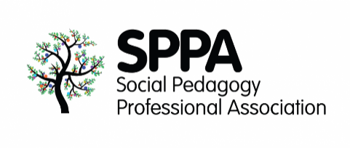SPPA Annual Conference

Online

September 2021*

Social Distance and Togetherness:

The Role of Social Pedagogy in Navigating Difficult Journeys

Abstract submission form

To submit an abstract please complete this form and return it to [**info@sppa-uk.org**](mailto:info@sppa-uk.org) with the subject: SPPA conference 2021 abstract

# Which format will your participation take?

Workshop Storytelling Lightning talk Poster

# Title of the session:

# Authors or facilitators

**Name:**

**Email**:

**Name:**

**Email:**

1. **Please tell us a bit about you in a few lines:**

1. **Abstract (250 words max)**

**Please make sure you specify:**

* the aim or purpose of what you intend to present and what your session or poster is about
* how your work connects to the topic of the conference
* if it is a workshop, please include how you plan to actively engage the attendees and a general description of the structure of the session

Thank you for your interest in participating in the SPPA annual conference. We will review your abstract and will get back to you soon.

If your abstract is selected, please bear in mind that **to present at the conference you must book a conference ticket in advance. We will be offering Early bird rates and special deals.**

**We are looking forward to hearing from you!**

**If you have any questions, please do contact us at** [**info@sppa-uk.org**](mailto:info@sppa-uk.org)

**All the best,**

**The SPPA team**