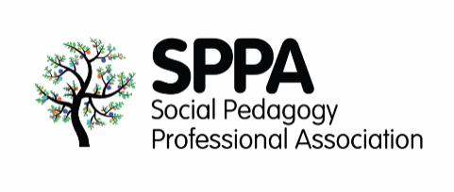SPPA Annual Conference

Online

September 2021*

Social Distance and Togetherness:

The Role of Social Pedagogy in Navigating Difficult Journeys

**Vlogs submission form**

**General guidelines:**

* vlogs should be a maximum of 5 minutes long
* please make sure there are no offensive images or language in your video
* check that that quality of the video is good enough to be displayed on a big screen but avoid sending files that are too large (3-4 GB max).
* we accept the following formats: MP4, MOV AND WMV
* we prefer landscape mode
* please fill in all the information in this form and submit both your vlog and this form via Dropbox using the link provided below

1. **Title of your Vlog:**
2. **Author(s)**

Name:

Email:

Name:

Email:

1. **Please explain briefly how your Vlog relates to this year’s theme (150 words max):**
2. **Please tell us a little bit about you in a few lines**
3. **Please review the following before submitting your video:**

I /we confirm that the author(s) stated above are the original authors of this Vlog

I/we are aware that this short video might be displayed at the SPPA conference 2021 and will be watch by a large audience

I/ we have permission from the people in the footage to show their faces or voices in this Vlog

1. **Instructions to upload your form and Vlog:**
2. Please save **both** your Vlog and this form as follows:

Form_Surname of first author_Initial of your first name_ Title of your blog

Vlog_ Surname of first author_Initial of your first name_ Title of your blog

*Example:*

Form_Smith_C_My social pedagogy journey.doc

Vlog_Smith_C_My social pedagogy journey.mp4

1. Click the Dropbox link to upload your files:

[**Submit your vlog & form here**](https://www.dropbox.com/request/1d4klp6iUd3KxS2CGEI8)

1. You should receive an email from Dropbox confirming your files have been successfully uploaded.
2. The SPPA team will email you (within 2-3 days) to acknowledge receipt of your files.

Thank you for your interest in participating in the SPPA annual conference! We will review your Vlog and will get back to you soon.

If you have any questions, please contact us at [**info@spp-uk.org**](mailto:info@spp-uk.org)

**All the best,**

**The SPPA team**