[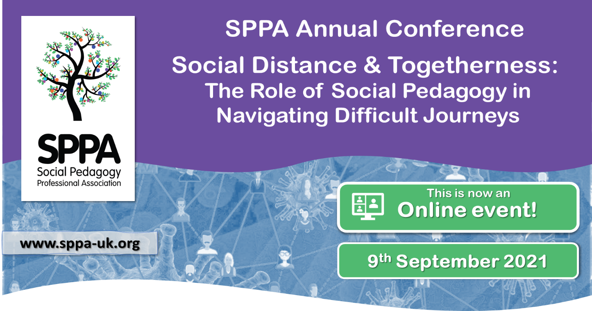](https://sppa-uk.org/upcomingevents/?event=60&events=cur)

CALL FOR ABSTRACTS

****The Social Pedagogy Professional Association [SPPA] is pleased to invite you to submit abstracts for our **Online** annual conference. The SPPA conference and this call for abstracts is **open to members and non-members** alike. We welcome proposals from practitioners, academics, policy makers, students, professionals and people interested in and/or passionate about social pedagogy from across a range of disciplines. The focus of your abstract should fit broadly within the topic of this year’s conference.

**The deadline for submissions is 15th May 2021**

# About this year’s theme:

Social Distance and Togetherness:

The Role of Social Pedagogy in Navigating Difficult Journeys

2020 has seen us all affected by social distance: physical, emotional, social and spiritual distance alike.

This distance has been challenging, but has also birthed new ways for togetherness, and unearthed old senses of community. There have been collective and individual journeys, both trying and transformative, and the role of social pedagogy has never been more pertinent when geographical, demographic, socio-economic and political landscapes have become so evident in their force behind shaping these journeys.

SPPA is gathering speakers from various disciplines to investigate social pedagogy’s role in the global and local navigation of this challenge, and from there, to think about its role in all journeys, from the everyday to the life-long.

This conference offers an exclusive opportunity to take stock, to reflect on our shared and individual journeys, and to look at how we have come together through social pedagogy and what its role is in the future.

We welcome you in shaping this conference with us!

# Ways to contribute

For the conference we offer a variety of ways to participate to allow for more interactive and diverse exploration of our theme of **Social Distance and Togetherness: the role of social pedagogy in navigating difficult journeys.**

## Workshops (45 min)

We are looking for creative, interactive, experiential workshops that are academically rooted or informed and come from a social pedagogical perspective. Workshops should aim to both inform and actively involve participants.

## Lightning talks (10 min, plus 5 min Q&A)

An opportunity to give a brief talk or share a story in an insightful and clear way. We aim to have a variety of speakers and topics (related to our theme of course) which could include experiences from life, practice, provocations or insights of social pedagogical approaches and concepts.

## Poster

We welcome posters that visually communicate projects, research, examples from practice or theoretical approaches. The posters will be displayed during the whole conference. There will be time during the breaks and lunch time for the authors to interact with attendees.

## Vlog (5 min)

We want to hear from you about your social pedagogy experiences, wisdoms, or key take home messages. This is an opportunity to participate in sharing your journey via a short video blog which will be played on loop through the breaks and lunchtime.

# Submission guidelines

**The deadline for submissions is 15th May 2021**

# Abstract submission for workshops, lightning talks and posters

Abstracts must show how your contribution relates to the conference theme, specify your aim and provide a brief explanation of the session or poster. Abstracts should be a maximum of 250 words. Please download and fill in the **abstracts submission form** and return it to [**info@sppa-uk.org**](mailto:info@sppa-uk.org)with the subject: SPPA conference 2021 abstract

[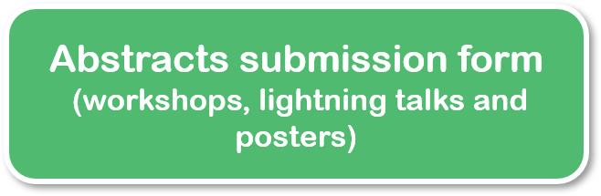](https://sppa-uk.org/wp-content/uploads/2021/03/Abstract-form_SPPA-conference-September-2021.docx)

# Vlogs submission

Vlogs should be 5 minutes long maximum, you can make a video with your phone or other device, please make sure there are no offensive images or language in your video. Check that the quality of the video is good enough to be displayed on a screen but avoid sending files that are too heavy. We prefer landscape mode.

We accept the following formats: MP4, MOV and WMV. Please download and fill in the **Vlog submission form** and send both your video and the form via Dropbox (see the Vlogs submission form for specific instructions).

**[Submit your Vlog here](https://www.dropbox.com/request/1d4klp6iUd3KxS2CGEI8)**

**Vlogs submission form**

Alternative you could send you vlog via [Wetransfer](https://wetransfer.com/) or email to [info@sppa-uk.org](mailto:info@sppa-uk.org).

# Who is this conference for?

Social pedagogy is a professional discipline that can be applied across the whole lifespan so we welcome a wide variety of submissions, from practitioners to policy makers, and students to academics, community activists to members of the public these may include:

* + Anyone interested in a social pedagogical, relational approach
  + People who have used or currently use services
  + Anyone interested in making new connections
  + Anyone who is keen to develop their learning about social pedagogy
  + Anyone keen to get into dialogue about wellbeing and educational solutions to social problems

You might be working in early childhood education and care, family support, youth work, children’s foster care, residential childcare, social work, services for older people, mental health services, community support services, employment support, community arts or any of the support and helping services and professions.

# Tickets

Get your tickets on [**Eventbrite**](https://www.eventbrite.co.uk/e/sppa-annual-conference-2021-tickets-136364185951) **or**[**contact us**](https://sppa-uk.org/upcomingevents/info@sppa-uk.org)**if you prefer to pay via invoice or make a bank transfer.**

Prices from £20 to £95. Book you tickets soon and get advantage of the Early bird rate!

All SPPA members get discounted tickets for the conference!

**](https://sppa-uk.org/membership/)**For information please [**visit our website**](http://www.sppa-uk.org) or email us: [**info@sppa-uk.org**](mailto:info@sppa-uk.org)

[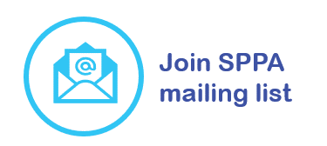](https://sppa-uk.us14.list-manage.com/subscribe?u=1a5b78ec5be4a74393ef144f1&id=dd7d5cf8d6)

Follow us on social media:

](https://www.linkedin.com/company/social-pedagogy-professional-association/)